**Your responses from the first section of the homework.**

True Positives (TP): 26

False Positives (FP): 3

True Negatives (TN): 150

False Negatives (FN): 21

Precision: 0.9

Recall: 0.55

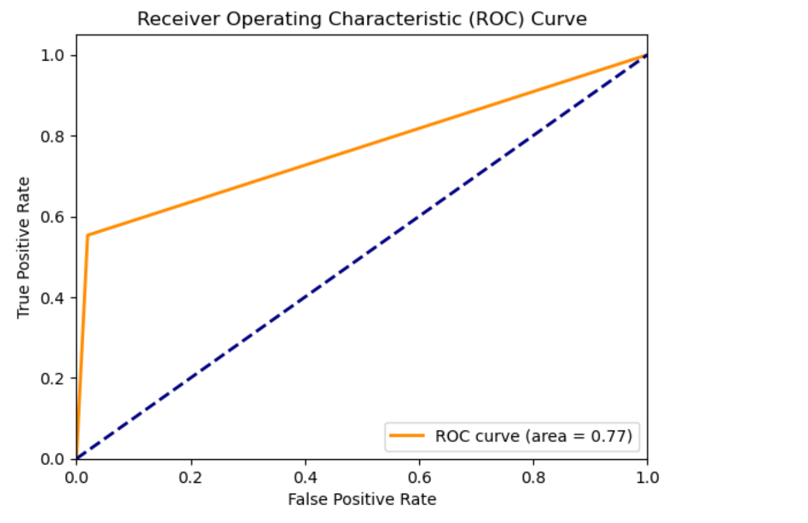

ROC-AUC=0.77



**Your target image class (i.e. what are you trying to recognize)**

• We are training the model on an apple vs. non-apple dataset.

• We are recognizing whether the given image is an apple or not.

**Number of parameters in your model.**

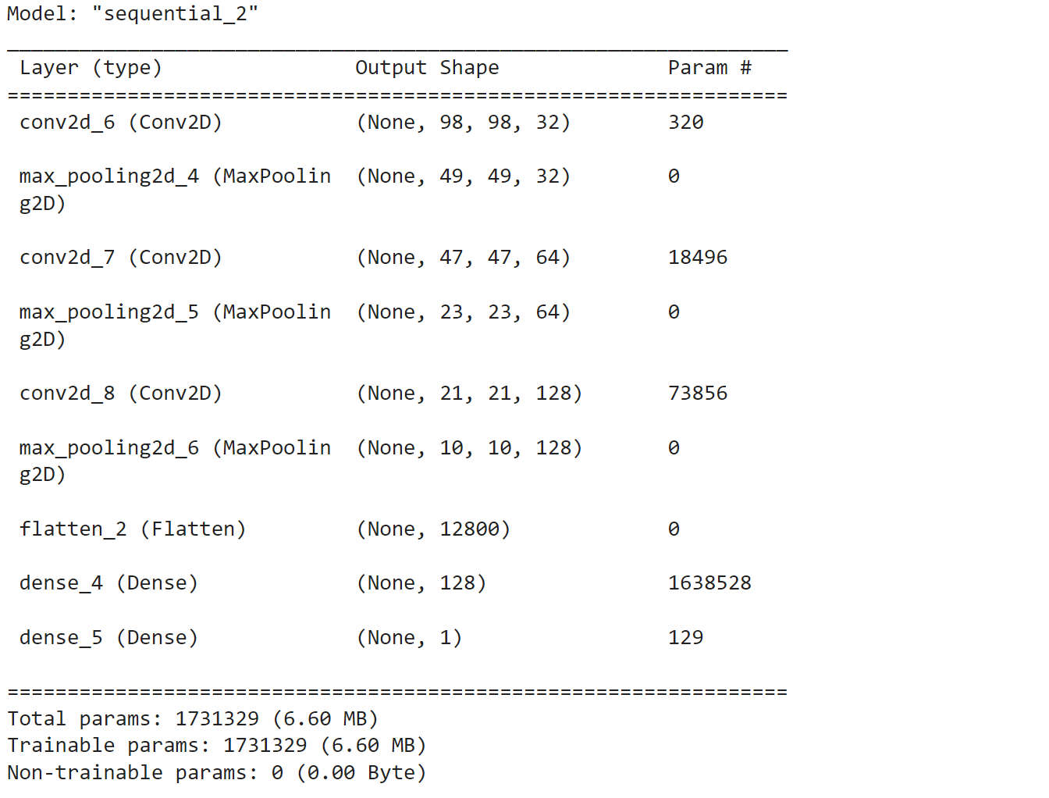

Total Parameters : 1731329

**Training and testing accuracy on your dataset.**

Training Accuracy : 80%

Testing Accuracy : 69%

**Number of positive and negative images in your dataset**

Number of Positive Images (Apple) : 5

Number of Negative Images (Non Apple) :5